**TERM 1 - 2025**

**BIOLOGY – PAPER TWO (231/2)**

**FORM FOUR (4)**

**MARKING SCHEME**

**Question 1**

1. Effectof high temperature on enzymes; ***1x1= 1 mark***
2. **P** colour of iodine retained starch absent; ***1x1= 1 mark***

**Q** colour of iodine turned blue black starch present; ***1x1= 1 mark***

1. **P** enzyme/ salivary amylase is active, starch was digested to maltose ***1x1= 1 mark***

**Q** enzyme/ salivary amylase denatured by heating/ boiling saliva, starch was not broken down / digested to maltose ***1x1= 1 mark***

1. Provide optimum temperature for enzyme action; ***1x1= 1 mark***
2. i) glycogen; ***1x1= 1 mark***

ii) starch; ***1x1= 1 mark***

**Question 2**

(a) 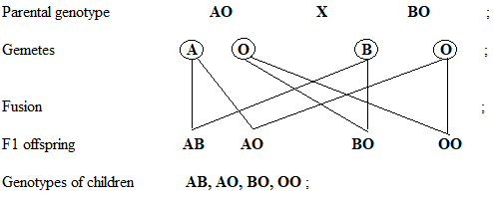

***4x1= 4 marks***

(b) 1 Blood Group AB : 1 Blood Group A : 1 Blood Group B : 1 Blood Group O ; ***1x1= 1 mark***

(c) (i) Blood group AB; ***1x1= 1 mark***

(ii) Lack antibodies; hence receive blood from all blood groups without triggering an antigen-antibody reaction; ***1x1= 1 mark***

(d) Massive destruction of red blood cells of the foetus due to antigen-antibody reaction of Rhesus positive and negative blood; ***1x1= 1 mark***

**Question 3**

1. Oxygen; ***1x1=1 mark***
2. Presence of light; presence of chlorophyll; suitable temp/ optimum temperature; ***2x1= 2 marks***
3. Palisade cells; palisade mesophyll; spongy mesophyll; ***2x1= 2 marks***
4. Photosynthesis; ***1x1= 1 mark***
5. Fatty acids; and amino acids; ***2x1= 2 marks***

**Question 4**

1. Where organism in various trophic levels don’t exceed the carrying capacity; ***1x1= 1 mark***
2. 500 + 1200+5000+10 = 6710g or 6.71kgs ***2x1= 2 marks***
3. (i) Water plants; ***1x1= 1 mark***

(ii) Fishes; ***1x1= 1 mark***

Water Plants

Insect Larva

Fishes

Bacteria

Each ½ mark

Arrow points at the feeder ***6 x ½ = 3 marks***

**Question 5**

1. P. Hair follicle; ***1x1= 1 mark***

Q. Sebaceous gland; ***1x1= 1 mark***

R. Sweat gland; ***1x1= 1 mark***

b)

Q. Secretes sebum; ***1x1= 1 mark***

T**.** Consist of actively dividing cells that produce new cells to replace cells lost/cells contain melanin that protect skin against harmful ultraviolet rays from the sun; ***1x1= 1 mark***

1. It secretes sweat, water in sweat evaporates; carrying away latent heat of vaporization hence leaving a cooling effect; ***1x1= 1 mark***
2. Reception of stimuli;

Protection of internal organs and tissues;

Storage of fat;

Excretion;

Synthesis of vitamin D; ***2x1= 2 marks***

**Question 6**

(a)

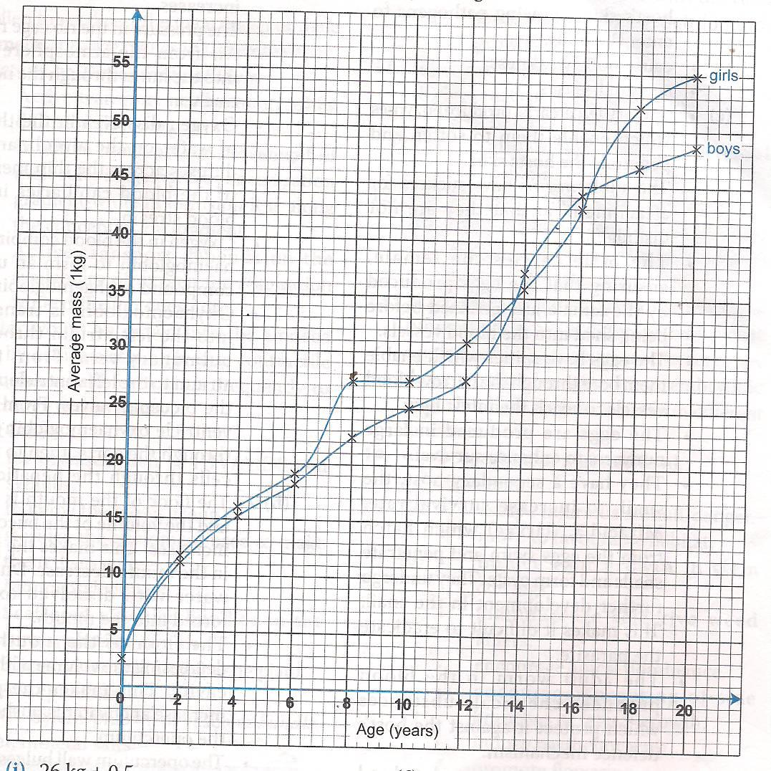

Scale: 1mk ×2=2mks

Axes: 1/2mk ×2=1mk

Plotting: 1mk ×2=2mks

Curve: 1/2mk ×2=1mk

Labeling: 1/2mk ×2=1mks

(b)

(i) 26 kg; +_0.5 ***1x1= 1 mark***

(ii) Girls 15 years -39

Girls 13 years -33

39-33 =6/2= 3.0kgs/year ***3x1= 3 marks***

(c) There is an increase in mass; because girls at adolescence grow faster;

(d) Girls generally grow faster than boys; boys grow slowly compared to girls but later after puberty they grow more steadily; ***2x1= 2 marks***

(e) Menstruation cycle begins hence they need more iron to replace blood lost during menstruation;

***1x1= 1 mark***

(f) Genetic composition;

Sex of the child;

State of health

Emotional status ***2x1= 2 marks***

(g) Height of the body;

Volume of the body; ***2x1= 2 marks***

**Question 7**

Comparative anatomy / taxonomy;

Members of a phylum / group show similarities ; organisms have structures / organs performing the same function ; e.g. digestive system ; nervous system same function etc (any correct example 1mk)

The pentadactyl limb / any correct example; these are called homologous organs / structures; homologous (same origin but have different function; Analogous structures / different structures performing the same function e.g. wings of insects, bat and birds; Analogous – different origin but performing same function;

Fossil records / Paleontology; remains of organisms preserved in naturally occurring materials for many years; show morphological changes of organisms over a long period of time; e.g. skull of man ( leg of horse)

Comparative embryology; embryos of vertebrates have similar morphology; suggesting the organisms have a common origin / ancestry ;

Geographical distribution; continents present are thought to have been a large landmass; joined together; as a result of continental drift; esolation; occurred bringing about different patterns of evolution; e.g. Llamas in the Amazons resemble the camel / any other correct example e.g. kangaroo in Australia Jaguar in S. America; camel in Africa;

Comparative serology / physiology ; antigen – antibody reactions / RH factor/ blood groups / haemoglobin structure reveal some phylogenetic relationship among organisms / common ancestry.

**Max 20mks**

**Question 8**

* Has secretory glands / crypts of lieberkuhn which secretes enzymes (maltase / sucrase / peptidase / lipase to complete digestion of lipids / sugar / proteins.
* Goblet cells secrete mucus allows for smooth movement of food / protect wall of ileum from action of digestive enzymes
* Very long to provide large surface area for absorption
* Highly folded / coiled to slow movement of food to allow more time for digestion / absorption / increase surface area for absorption.
* Has numerous villi which increase surface area for absorption / microvilli which further increase surface area for absorption.
* Ileum wall / villi have thin epithelium which is only one cell thick to reduce distance over which digested food has to diffuse.
* Villi are highly vascularized / have a rich network of blood capillaries for rapid transport from small intestines / maintain a steep concentration gradient.
* Villi have lacteals for absorption of fatty acids and glycerol
* Cells of the ileum wall have a large count of mitochondria to release energy that aids in active transport across the epithelium.

**Max 20mks**